# Montréal Digital Poster Revolution

In the beginning, there were only traditional paper posters. As time progressed and computers got cheaper, we introduced electronic posters on small screens. We lived in this dual environment and were reasonably happy with it – until now.

Starting in Montréal, we will have the best of both worlds. We will no longer have traditional or electronic posters. Instead, we are introducing **digital posters**, posters displayed on beautiful large 2k 43-inch diagonal (37-inch wide) high-definition flat panel displays. Much like changing from reading films to PACS, this technology represents the evolution of the field, and will come with significant cost saving to the Society.

For those that love browsing traditional 36-inch square paper posters, this new digital poster technology comes with a browse function (“next poster” and “previous poster” controls) that allows you to rapidly view posters in succession, in essence bringing the posters to you rather than you walking amongst the posters. Presenters who choose this single-slide option can present all of their work at once, just as is done now for traditional posters.

Additionally, with the new digital poster technology, we also gain flexibility to do other slide formats. Imagine a “Harry Potter” newspaper effect: a single slide poster containing static text, with embedded moving animations for the figures. If you are a fan of presenting E-posters, a short slide show will suffice. Anything is possible. And with online poster submission, no more worries about printing out the poster, bringing it to and from the meeting, paying for the paper, etc. As before, all posters will have assigned poster presentation times. Come check out the new digital posters in Montréal!

**New Requirement:  
Teaser Slide**

All Digital Poster submissions must include a single “teaser” slide **in .jpg format.** It will appear on the D-Poster screens between poster sessions as part of a looping slide show, allowing viewers to click on any slide to view the corresponding D-Poster.

[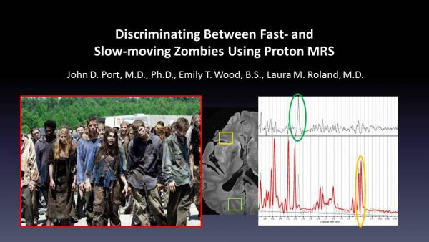](https://blog.ismrm.org/wp-content/uploads/2019/03/ZPoster_Teaser.jpg)  
*Example teaser slide.*[*Get the .pptx file*](https://blog.ismrm.org/files/19m/ZPoster_Teaser.pptx)*.*

The Teaser slide should only include the title, authors, and a few visually interesting pictures to intrigue the viewer. After creating your single slide, please **export it as a .jpg file** for submission. Jpg is the only acceptable format for the teaser slide.

A digital poster (D-Poster) is a poster in PowerPoint format, allowing the inclusion of movies, and other multi-media formats, and presenters are encouraged to take advantage of the versatility of this medium. All multimedia D-Posters will be presented at numbered monitors in the Exhibition Hall. The time allotted for D-poster presentations is 60 minutes, and authors are requested to be at their assigned computers for the period of time specified in the acceptance message. During this time you will be available for discussion of your D-Poster.

If you are scheduled to present two posters during the same 1-hour period, please plan to spend 30 minutes at each poster. While we strive to minimize overlap of presentations, some are unavoidable and cannot be rescheduled.

You will be informed of your program number as well as your computer assignment before the meeting. However, when you arrive at the meeting, **check the program to confirm** the day, time and monitor for your presentation, in case there have been last minute changes.

Although it is preferred that the first author present their work, a co-author or institutional colleague may make the presentation if the first author is unavailable. We do not require notification of this.

Presentations that are submitted on-site in the speaker ready room may not be available for viewing in the poster hall immediately. Please review your submission thoroughly before submission.

**D-Posters can be identical to our E-Poster format from previous years.**  
[Click here to view an example E-Poster](https://www.ismrm.org/17/other/eposter_sample_4309) from 2017.

**Maximum presentation size: 200 MB**

On-site computer & software details are in the Quick Details column to the right.

Other important notes:

* The monitors displaying the presentations will be widescreen 16:9 [rectangle] format.
* All animations and video files must be set to play automatically.
* Slides will be advanced by mouse click.
* Presentations will be produced for the web after the conference. Each slide will display approximately 7 seconds.
* Avoid using small images and text if possible.
* Check your presentation for hyperlinks (links to the Internet, e-mail addresses, or other documents) and remove them.
* There are no computer speakers, so please do not include audio in your presentation.
* PC users should use the [**EMBED FONTS**](https://support.microsoft.com/en-us/kb/826832) feature in PowerPoint to make sure your text displays as intended.

**A note to Apple Macintosh users:**  
The PowerPoint file must have the .ppt or .pptx suffix to be accepted.

**Contact Information and Presentation Upload Instructions**

All digital poster presenters may upload their presentation via the meeting website, **which will open on or about 19 April 2019 and close 01 May 2019, 11:59 EDT.** No online submissions will be accepted after this date, however, you may upload your poster in the speaker ready room in Montreal. Please be aware that we recommend you upload your poster in advance, as we expect the speaker ready room to be very crowded. First authors will be sent an email with instructions on or around the date the upload site opens. If you do not receive this email, please email us: [ismrm@ets-av.com](mailto:ismrm@ets-av.com).

**The Speaker Upload Site will be Open from 19 April through 01 May 2019  
The link is in the blue “Quick Details” column on this page.**

For Speaker Ready Room questions, please contact:  
Event Technology Services  
[ismrm@ets-av.com](mailto:ismrm@ets-av.com) *

**\* Please DO NOT EMAIL presentations!** Presentations that are e-mailed **will not be accepted.**

**Basic Content Guidelines**

The following are suggested guidelines for those who are new to presenting digital posters, or anyone else looking for basic ideas to start a new presentation. If you attended last year’s meeting in Paris, you may review the [E-Poster videos that are available to attendees](https://www.ismrm.org/18m/program-at-a-glance/) for ideas which may be helpful in designing your presentation.

* There should be a running title at the top of all slides. This allows people to walk up in the middle of a presentation and understand immediately which poster is being presented. This should include both program number and title. Separate the running title and program number visually. For example, if the text and number are placed within a box of a slightly different color, they would be separated visually.
* Each slide title should be placed in a title placeholder. This allows that title to come across in the hyperlinks on the left bar.
* Consider putting something catchy into the title slide. Examples are a key result, a key picture, or a sentence describing the major result of the poster.
* The first slide should show the full title of your submission.
* The poster should be self-explanatory. Text should be brief and well organized.
* The text should make clear the significance of your research.
* The text should include (most likely as separate elements of the poster) your hypothesis, methods, results, and conclusions.

**Speaker Ready Room:  
514 ABC**

**Hours of Operation:**

|  |  |
| --- | --- |
| Friday, 10 May | 14:00-20:00 |
| Saturday, 11 May | 06:30-18:00 |
| Sunday, 12 May | 07:00-18:00 |
| Monday, 13 May | 06:30-18:30 |
| Tuesday, 14 May | 06:30-18:00 |
| Wednesday, 15 May | 06:30-18:00 |
| Thursday, 16 May | 06:30-18:00 |

**Computers & Software**

All computers in the Speaker Ready Room and Session Rooms are the same, including the **latest versions** of the following software:

* PC: Windows 10, Microsoft PowerPoint, Adobe Acrobat Reader
* Mac: MacOS, Microsoft PowerPoint, Apple Keynote

Recommended video formats:

* PC: Windows Media Video (.wmv)
* PC: MPEG4-AVC (.mp4)
* Mac: QuickTime Movie using the H.264 CODEC (.mov)

**FAQ**

***Why can’t I use Apple Keynote, Adobe Acrobat (.pdf), or Adobe Flash (.FLA) for the digital poster area?***  
The software used to convert digital & electronic posters into web-friendly files does not support Keynote, Acrobat, or Flash native files.

***Why not just use Macintosh computers in the digital poster area?***  
The web browser on the Macintosh computer does not support embedded PowerPoint files. To make this function work would entail extensive software development. This feature is built-in to the Windows operating system and Internet Explorer.

# Slide Design Guide

***Please observe these basic rules:***

* Each slide should illustrate a single point or idea.
* Use large, legible letters.
* Do not crowd the slide.
* Message slides should contain no more than 7 lines, with 7 or fewer words per line.

**General PowerPoint Slide Guidelines:**

* **Keep the data on slides simple**. If you have a great deal of data, divide it among several slides. The content of a single slide should be easily comprehended in 20 seconds. Remember: seven lines per slide and seven words per line!
* **Use large, legible letters.** Be sure to use the [**EMBED FONTS**](https://support.microsoft.com/en-us/kb/826832) feature in PowerPoint to make sure your text displays as intended.
* **If your data slides are in color**, use only light colors, such as white and yellow, on a dark background, such as dark blue. Do not use colors such as red or purple.
* **Keep slides of radiographs light**. Dense or dark slides project poorly in large rooms. Enlarging the significant areas and using arrows to point out the specific area or lesion often helps.
* **Patient confidentiality must be protected**, and the patient’s a right to privacy should not be infringed without express informed consent. This includes removing identifying text in images, providing graphical overlays onto photographs, etc. No names should appear on the images.
* **Avoid commercial reference** unless mandatory. A logo or institutional identification should appear only on the first title slide. Do not use such identification as a header on each slide.
* **Limit the number of slides** to no more than one (1) for each minute of your presentation. The slides should not contain your entire presentation. Their purpose is to support your talk and to emphasize the important points.
* **For Digital Posters, set your slide show to loop continuously.** Under SETUP SLIDE SHOW, choose LOOP CONTINUOUSLY.

**Word Slides:**

* Title of text slides should contain five or fewer words.
* Spaces between lines should be at least the height of an upper case letter.

**Tabular Slides:**

* Use graphs rather than tables if possible.
* Keep tabular slides as brief as possible.
* Two or more simple slides are better than one complicated slide.
* Make the font as large as possible.
* Do not crowd the slide.

**Graph Slides:**

* Keep graphs simple.
* Round off figures.
* Limit the number of captions.
* Use line graphs to show trends or changing relationships.
* Use bar graphs to compare volumes.

**Chart Slides:**

* Simplify charts to keep them legible.
* Break up complex charts into a series of slides.

# Digital Poster How-To Guide

[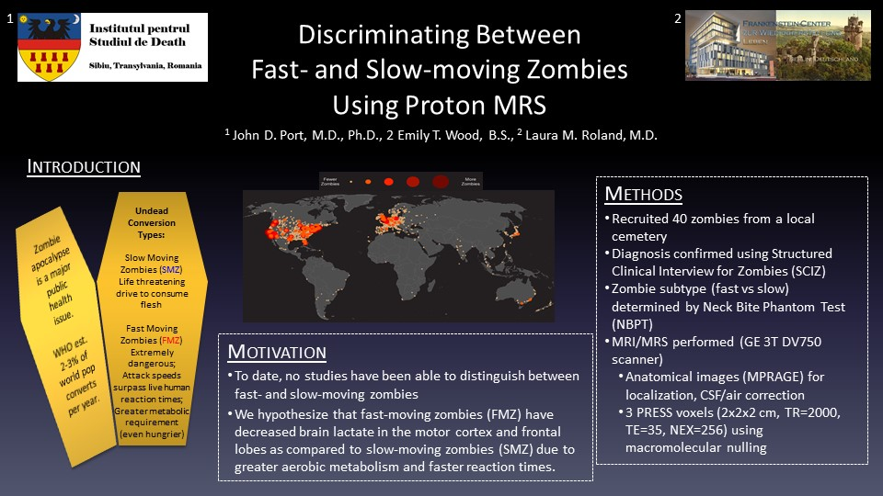](https://blog.ismrm.org/wp-content/uploads/2019/03/Slide1.jpg)

[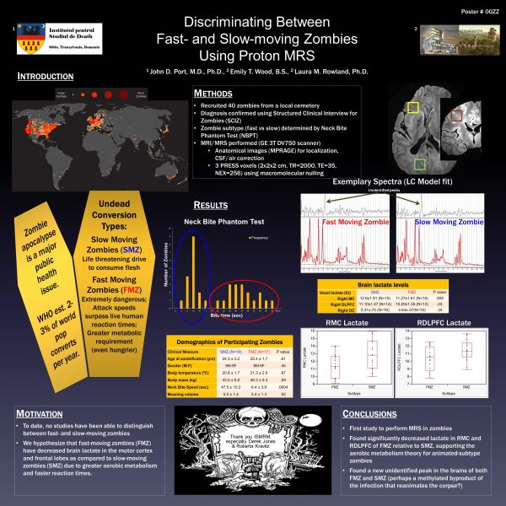](https://blog.ismrm.org/wp-content/uploads/2019/03/ZPoster_original.jpg)  
[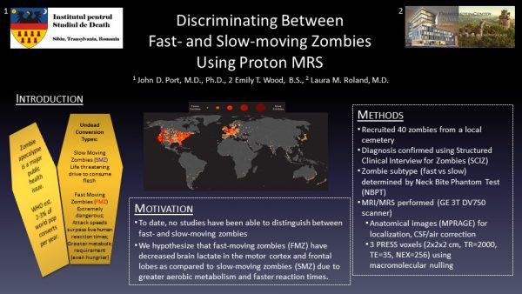](https://blog.ismrm.org/wp-content/uploads/2019/03/Slide1.jpg)

As many of you have already heard, the ISMRM is making the [epic leap to all digital posters for the 2019 Annual Meeting](https://blog.ismrm.org/2018/10/08/montreal-digital-poster-revolution/) in Montréal. So as your abstracts have been accepted, and you are starting to put together the content of your posters, the question abruptly arises: How do you assemble a digital poster?

If you’re like me, you dust off the Powerpoint or Keynote file of your poster from last year and modify it to make your new poster. Those posters were 36 inches wide by 36 inches tall, setup to print on paper, and used font sizes in points (where 1 point = 1/72 of an inch). So titles were typically 72 points (1 inch), headings were typically 54 points (3/4 inch), the main text was typically 36 points (1/2 inch), and the fine print (used for references, etc) was typically 24 points (1/3 inch).

Yikes! How do you convert that to display well on a 43-inch 16:9 high-definition 1080p digital monitor? First, a little background. A 43-inch diagonal monitor is approximately 37 inches wide by 21 inches tall. So width is no problem, it’s a little wider than a paper poster. BUT it’s definitely shorter, so the problem arises – how do we squeeze 36 vertical inches of content into 21 inches of height? And what font sizes should I use for the digital environment? 1920 by 1080 pixels divided by 37 by 21 inches? Arrgh!!!

Ok here’s the scoop. First, set the presentation for on-screen display. In Powerpoint, go to **File->Page Setup…**, click on **Slide sized for:** and select **On-screen Show (16:9)**. Do NOT change the width or height, just click ok. You will probably get an error message stating “You are converting to a smaller slide size. Do you want to scale content down?” Just select the **Scale**button. In Keynote, click the **Document** button in the top right of the window. Make sure the **Document** tab is selected, then look for **Slide Size** and select **Widescreen (16:9)** from the drop-down menu. Your poster will now fit properly onto a 43″ monitor. BUT: the text got really small, too small to read at any reasonable viewing distance (i.e. 15-24 inches from the monitor. And there’s a lot of wasted space on the outside edges. What to do?

Some examples. I dusted off an old Power Pitch poster that I presented at the 2014 Annual meeting in Milan ([ZPoster_original.pptx](https://blog.ismrm.org/files/19m/ZPoster_original.pptx)). I resized it as described above, and got a fairly lousy looking poster ([ZPoster_resized.pptx](https://blog.ismrm.org/files/19m/ZPoster_resized.pptx)). I moved elements around and made a passable 1-slide “traditional poster” version, preserving as much content as possible. It wasn’t too bad, but I definitely needed to cut down the content ([ZPoster_Traditional.pptx](https://blog.ismrm.org/files/19m/ZPoster_Traditional.pptx)).

To preserve all the content, I modified it by splitting the presentation into two slides ([ZPoster_2slide.pptx](https://blog.ismrm.org/files/19m/ZPoster_2slide.pptx)). I put the Title, Introduction, and Methods on the first slide, and the Results, Discussion and References on the second slide. For font sizes, I use the “Divide by 3” principle – divide the paper-poster font size by 3. So use:

Title: 24 points  
Headings: 18 points  
Text: 12 points  
Fine print: 8 points

As for choice of font type, I am a big fan of using boring fonts. Calibri, Times, and Arial (or their equivalents) are available on most computer systems, and thus you will need very little (if any) modification of the poster once you’ve uploaded it if you stick to these common fonts. Plus Calibri has fixed-width numbers, so tables with numbers and decimal points are easy to line up. You can use fancy fonts if you want, but there are no guarantees that things will look good following upload. (Editor’s note: Don’t forget to [*EMBED FONTS*](https://support.microsoft.com/en-us/kb/826832)!)

The cool thing about digital posters is that you can do anything for your poster that you can do in a slide show. For example, you can add in animations ([ZPoster_2slide_animated.pptx](https://blog.ismrm.org/files/19m/ZPoster_2slide_animated.pptx)), movies, whatever you want. Also – as we allow up to 10 slides maximum per digital poster – you can setup your poster like our old-style electronic poster ([ZPoster_Eposter.pptx](https://blog.ismrm.org/files/19m/ZPoster_Eposter.pptx)).

[](https://blog.ismrm.org/wp-content/uploads/2019/03/ZPoster_Teaser.jpg)  
*Example teaser slide*

Also new this year as part of D-posters, we’re requiring everyone to **submit a single “teaser” slide in .jpg format.** It will be used like a screen saver on the monitors in between poster sessions. The Teaser slide (example: [ZPoster_Teaser.pptx](https://blog.ismrm.org/files/19m/ZPoster_Teaser.pptx)) should only include the title of the talk, the authors, and a few small pictures selected to grab someone’s interest and make them want to know more about your work. After creating your single slide, please **export it as a .jpg file.** Jpg is the only acceptable format for the screen slide.

One final point – you can only upload D-Posters in PowerPoint format. So if you use Keynote, as a last step, go to **File -> Export To -> PowerPoint…** and follow the steps to save the file.

As we’ve never done anything like this before, it’s impossible to predict how people will make their posters this year. **The most important thing is to present your science well,** but secondarily, be creative and have fun!